


Multi-Functional Cane

ELBC803- Embedded Design Project
By

Ali Yazbeck – 94764
Serena Haidar – 90457
Zein Attar - 94266

Submitted to the Faculty of Engineering of the
Islamic University in Lebanon
Baalbek, Lebanon
In partial fulfillment of the requirements for the degree of

BACHELOR OF ENGINEERING IN COMPUTER AND COMMUNICATIONS
Spring 2024-2025

Approved by:
Dr. Mohammad Chreif

TABLE OF CONTENTS

CHAPTER 1 INTRODUCTION 1
1. What Is Engineering? 1
2. Project Idea and Objectives 1
3. What Is the Arduino Mega 2560? 2
CHAPTER 2 System Design and Implementation 4
2.1 Introduction 4
2.2 Required Components 4
2.3 Circuit Design 5
2.4 Implementation Steps 6
2.4.1 LDR Sensor 6
2.4.2 GPS+GSM modules 7
2.4.3 Ultrasonic Sensor and Audio Feedback 8
2.4.4 Water sensor with buzzer 10
2.4.5. Rechargeable Li-ion batteries 12
2.5 Hardware 13
CHAPTER 3 Conclusion and Future Work 14
3.1 Conclusion 14
3.2 Future Work 14
CHAPTER 4 References 15

‘

LIST OF FIGURES

Figure ‎2-1 Complete circuit 5
Figure ‎2-2 Circuit 5
Figure ‎2-3 Led connections 6
Figure ‎2-4 Connecting Arduino to breadboard 6

INTRODUCTION

What Is Engineering?
Engineering is the disciplined art of applying scientific and mathematical principles to design, build, and optimize structures, systems, and processes for humanity’s benefit [1]. Fundamentally, engineering solves real-world problems, serving people and the planet alike, and propelling society forward [2].
The field branches into specialties such as biomedical, chemical, electrical, civil, materials, and mechanical engineering, each addressing unique challenges from health to infrastructure to energy. Beyond these fields, emerging and interdisciplinary domains, like environmental, aerospace, software, and mechatronics, illustrate engineering’s boundless reach across modern life [3].
Yet all engineers share a common framework: define requirements, model solutions, test prototypes, and refine designs until form and function unite seamlessly.

Project Idea and Objectives
Globally, over 2.2 billion people live with a near or distance vision impairment or blindness. Alarmingly, at least 1 billion of these cases are treatable or preventable, highlighting a profound need for assistive technologies [4]
Vision loss often leads to reduced independence, limited mobility, and an increased risk of accidents, especially when navigating new environments.
Today, existing mobility aids like traditional white canes, often rely on mechanical contact feedback. More advanced versions offer vibration alerts or audio cues, yet neglect hazards like water puddles, low-light visibility, or emergency signaling. These limitations leave visually impaired people vulnerable in critical situations.
To bridge this gap, our project presents a Multifunctional Smart Cane: an integrated assistive system designed to extend the capabilities of traditional canes using embedded technology.
Key features:
- Ultrasonic sensors to detect nearby solid obstacles
- A water sensor to identify slippery surfaces like puddles
- A GPS + GSM module to allow users to send location-tagged SOS messages in emergency cases
- An LDR-based lighting system that activates a bright LED in dark environments to increase user visibility
- A digital compass and sound module intended to provide directional orientation cues
- A rechargeable Li-ion battery system, ensuring portable, long-lasting operation.

Project Objectives:
- Detect obstacles and slippery surfaces: Using ultrasonic sensors for solid objects and a water sensor for puddles.
- Enable Emergency response: One-button system sends GPS coordinates via SMS using GSM module.
- Improve visibility in low-light: Automatic LED activation triggered by an LDR sensor to make the user visible to others.
- Assist with basic directional navigation: A digital compass paired with sound feedback to help orient the user.
- Ensure long-lasting operation: Powered by a rechargeable Li-ion battery for portability and efficiency.

By delivering these features, we address the fundamental challenges of safety, independence, and confidence for visually impaired users.

What Is the Arduino Mega 2560?
The Arduino Mega 2560 is a high-performance microcontroller board built around the ATmega2560 chip. It is designed for projects that require numerous inputs and outputs or complex control systems. With 54 digital I/O pins, 16 analog inputs, and 4 serial communication ports, it is well-suited for advanced embedded and automation projects, robotics, and large-scale sensor networks. [5]
Unlike boards with integrated wireless capabilities, such as the ESP32, the Mega 2560 relies on external modules (e.g., Bluetooth, GSM, or Wi-Fi) to extend its connectivity. It remains a popular choice for developers who prioritize pin availability and processing stability in large projects.
Arduino Mega 2560 Specifications [6]
- Microcontroller: ATmega2560
- Operating Voltage: 5V
- Input Voltage (recommended): 7–12V
- Input Voltage (limits): 6–20V
Memory
- Flash Memory: 256 KB (8 KB used by the bootloader)
- SRAM: 8 KB
- EEPROM: 4 KB
Digital and Analog I/O
- Digital I/O Pins: 54 (15 with PWM output capability)
- Analog Input Pins: 16
- PWM Channels: 15
- UARTs: 4 hardware serial ports
- Interfaces Supported: SPI, I2C, USB
Clocks and Timers
- Clock Speed: 16 MHz (external crystal oscillator)
- Timers: Includes hardware timers for PWM, timing, and interrupts
Others Features
- ICSP header for direct microcontroller programming
- Reset button, voltage regulator, and power jack
- Compatible with standard Arduino shields and the Arduino IDE

System Design and Implementation

Introduction
In this chapter, the components used in the Multi-Functional Smart Cane are presented, followed by a description of the systematic steps taken for its implementation.
The primary objective of this system is to enable visually impaired individuals to navigate their surroundings safely and independently by integrating sensors and modules for obstacle detection, location tracking, darkness detection, and emergency messaging.

Required Components
The following table lists all the components used to build the multi-functional smart cane. Each part was chosen based on its compatibility with the Arduino Mega 2560 and its relevance to the features we wanted to implement.

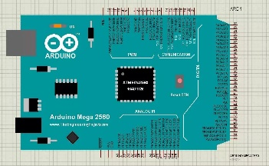 | ARDUINO MEGA-2560 x1  The brain of the system.
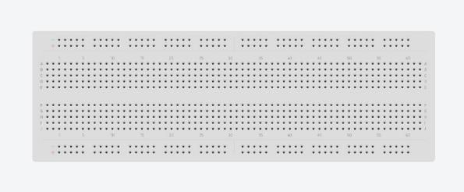 | Breadboard x1  For connecting components
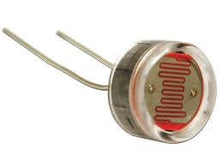 | LDR Sensor x1  Detects light intensity to automatically turn on a LED when it’s dark
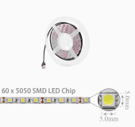 | LED Light Strip x1  Lights up the path in dark areas based on the LDR readings
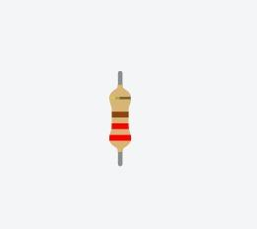 | Resistor 220-ohm x7  To implement electrical resistance as a circuit element
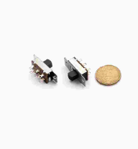 | Slide Switch, 6-pin ON_ON x1  To power the cane ON and OFF
Ultrasonic sensor 412 CH x3

To detect obstacles and send feedback to the DFPlayer
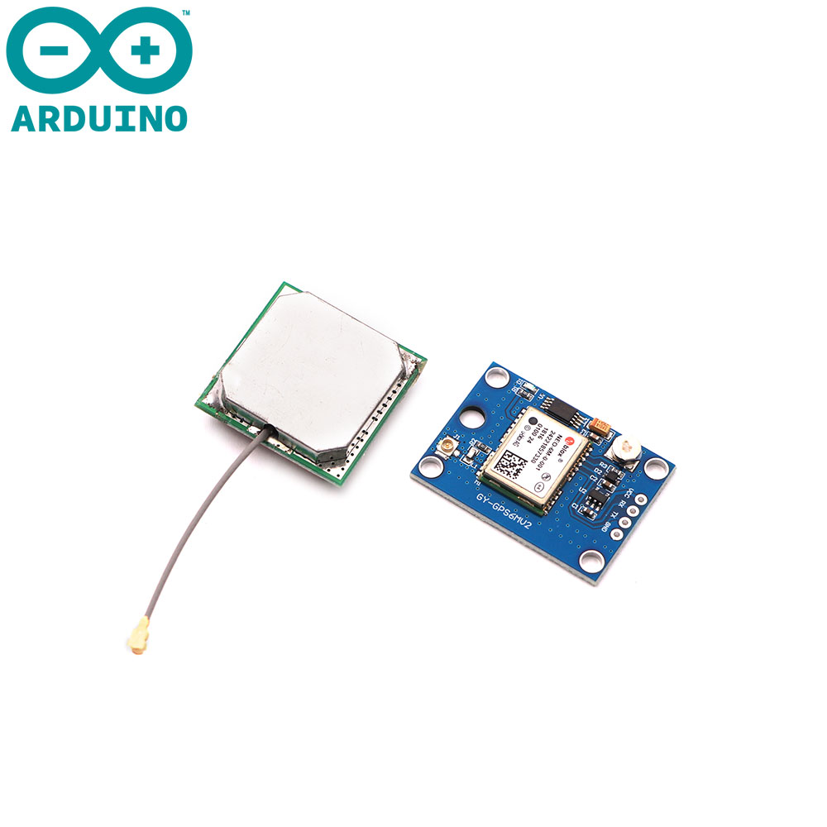 | GPS MODULE NEO-6MV2 x1  To acquire the location from satellites
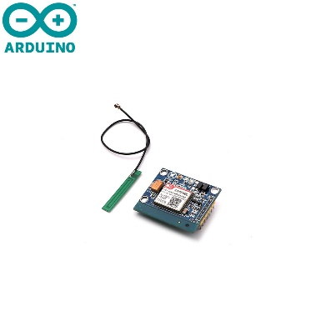 | GSM SIM800L Module x1  To send an SMS when the emergency button is pressed
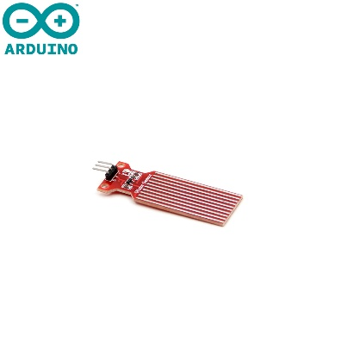
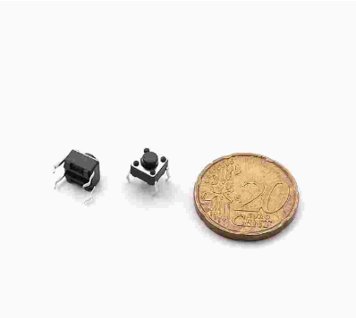 | Tactile switch 4-pin x1  Serves as an emergency button. When pressed, it activates the GSM module which sends the emergency SMS
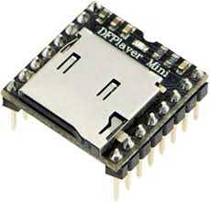 | DFPlayer module X1  kjklweflk
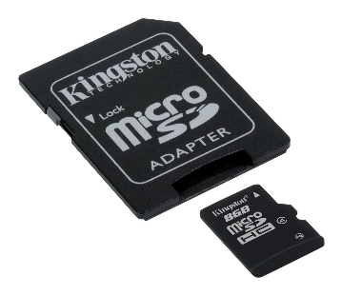 | Micro SD Card x1  To store the voice messages used for navigation feedback
Mini Speaker 4ohm, 3W x1

To play the sounds stored in the microSD card
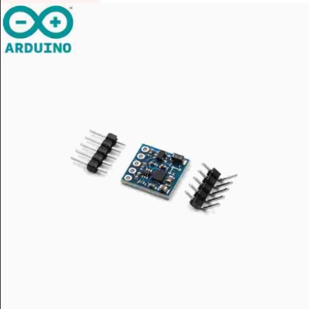 | Compass digital sensor x1  To orient the user
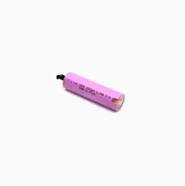 | Li-ion 18650 2200mAh TAG battery, 3.7V x2  To charge the cane

Circuit Design
Figure 2.1 shows the full circuit schematic of the system, which includes the Arduino Mega 2560 microcontroller, ultrasonic sensors, a GPS and GSM modules for emergency functionality, and other components connected with proper power management and grounding. ADD THE LDR SENSOR + LAMP + MISSING PARTS. IMAGE TO BE REPLACED
Figure ‎2.1 Full System Circuit Design
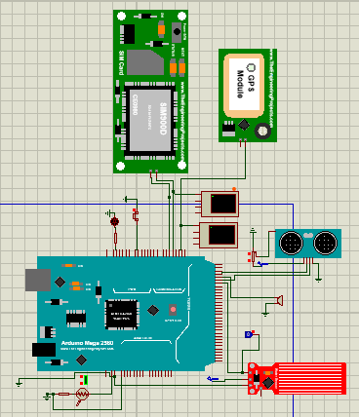

Implementation Steps

2.4.1 LDR Sensor

In this step, an LDR sensor is connected to the analog pin A0 and a LED to the digital pin A8 of the Arduino Mega 2560. When the LDR detects darkness (light level gets below a set threshold), the Arduino turns on the LED automatically. This feature helps the user to walk safely in low-light environments by turning on the light without any manual input.

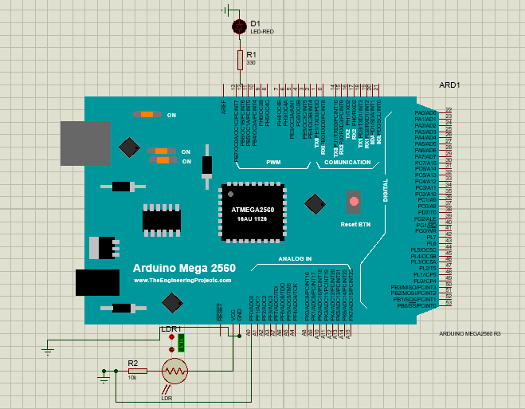
Figure ‎2.2 LDR and LED light circuit connected to Arduino Mega 2560

Code:
int ldrPin = A0; // LDR connected to analog pin A0
int ledPin = 8; // LED connected to digital pin 8
int threshold = 500; // Light threshold for darkness
void setup() {
pinMode(ledPin, OUTPUT);
Serial.begin(9600);
}
void loop() {
int lightLevel = analogRead(ldrPin); // Read light value
if (lightLevel < threshold) {
digitalWrite(ledPin, HIGH); // Turn on LED
} else {
digitalWrite(ledPin, LOW); // Turn off LED
} }

Explanation
- analogRead(): reads the light level from the LDR.
- If the value is less than 500 (dark), the LED turns on.
- If it's brighter, the LED stays off.
This ensures safer navigation for the user in the dark, making them more visible to others.

2.4.2 GPS+GSM modules
To assist the visually impaired person in case of an emergency, such as a fall, an injury, or getting lost, an emergency button is implemented. When pressed, it sends the person’s location coordinates in readable format, as a text message to a preset emergency contact.
The location is acquired from satellites using the GPS module, and the GSM SIM module send the message to a phone number.

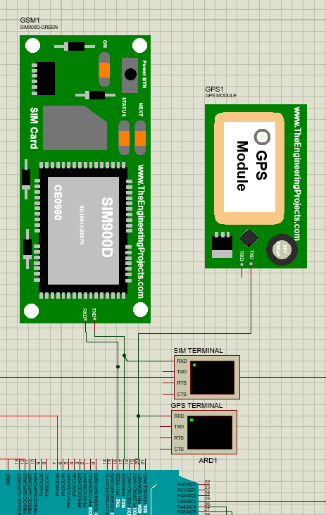

Wiring Overview:
The GPS and GSM modules both have 4 pins : TX, RX, VCC and GND.
- GSM module(fddafa):
  - VCC → 5V power supply
  - GND → Ground
  - TX → Connected to pin RX0 / ADx (pin 2x) on Arduino Mega
  - RX → Connected to pin TX0 / ADx (pin 2x) on Arduino Mega
- GPS module(fdaafadfa):
  - VCC → 5V power supply
  - GND → Ground
  - TX → Connected to pin RX1 /ADx (pin 2x) on Arduino Mega
  - RX → Not connected, since the GPS only sends and doesn’t receive information.

// insert code screenshot with some explanation to how the components work

2.4.3 Ultrasonic Sensor and Audio Feedback

In order to detect obstacles and avoid them, the cane needs to be equipped with ultrasonic sensors and provide immediate audio feedback.
The Arduino Mega reads input from the sensors, and when an obstacle is close, it activates the DFD Player Mini, which outputs voice messages stored on an SD card, guiding the user left or right.
For simplicity in the simulation phase, a buzzer feedback is implemented, and the distance controlled by a potentiometer.

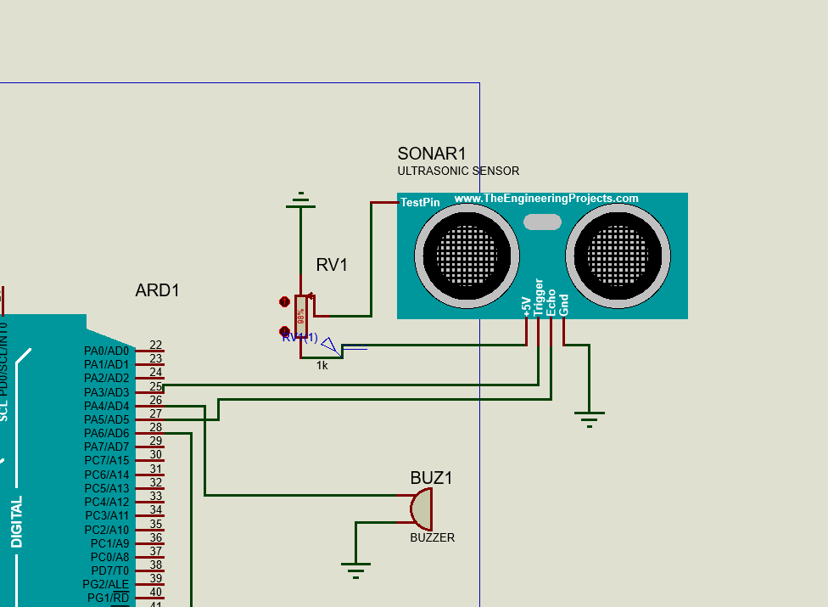
Figure 3:Ultrasonic sensor & buzzer wirings in Proteus

Wiring Overview:
The ultrasonic sensor has 5 main pins: Trigger, Echo, TestPin, VCC and GND.
- Ultrasonic sensor (HC-SR04):
  - VCC → 5V power supply
  - GND → Ground
  - Trigger → Connected to pin PA3 / AD3 (pin 25) on Arduino Mega
  - Echo → Connected to pin PA5 / AD5 (pin 27) on Arduino Mega
  - TestPin → Connected to the wiper of a potentiometer (RV1) to simulate distance changes

- Potentiometer (RV1):
  - One end to 5V
  - Other end to GND
  - Wiper (middle pin) → Connected to TestPin of the ultrasonic sensor, allowing the simulation of different distances by adjusting the potentiometer, mimicking how objects are positioned closer or farther.

- Buzzer:
  - Positive pin → Connected to pin PA4 / AD4 (pin 26) on Arduino Mega
  - Negative pin → Connected to GND

Code:
const int trigPin = 25; // Ultrasonic Trigger pin
const int echoPin = 27; // Ultrasonic Echo pin
const int buzzerPin = 26; // Buzzer control pin
void setup () {
pinMode (trigPin, OUTPUT);
pinMode (echoPin, INPUT);
pinMode (buzzerPin, OUTPUT);
Serial.begin(9600);
}
void loop () {
// Send ultrasonic pulse
digitalWrite (trigPin, LOW);
delayMicroseconds (2);
digitalWrite (trigPin, HIGH);
delayMicroseconds (10);
digitalWrite (trigPin, LOW);
// Read echo response time
long duration = pulseIn (echoPin, HIGH);

// Convert to distance (cm)
float distance = duration * 0.034 / 2;

// Activate buzzer if object is too close
if (distance > 0 && distance < 15) {
digitalWrite (buzzerPin, HIGH);
} else {
digitalWrite (buzzerPin, LOW);
}
delay (300); // Stabilize readings

The code continuously measures distance using the ultrasonic sensor, for real-time obstacle detection. It sends a short pulse, waits for the echo, and calculates the distance based on the time it takes to return.
- If the measured distance is less than 15 cm, it means that an object is near, which turns ON the buzzer to alert the user.
- If no nearby object is detected, the buzzer remains OFF.

2.4.4 Water sensor with buzzer

To avoid slipping on water puddles on the ground or wet surfaces, a water detection feature is implemented, with a water sensor and a buzzer. The water sensor + how it works.
To simulate this, a logic probe is used to detect water, providing a simple yet effective feedback system.
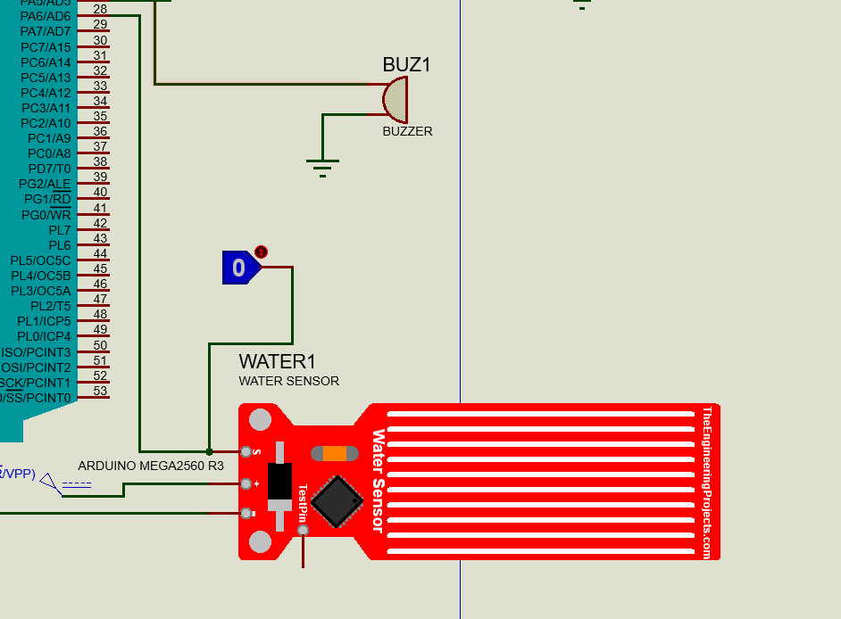

Wiring overview:
- Water sensor module:
This module has one main pin connecting to the Arduino Mega to signal the presence of water.
  - VCC pin → Connected to 5V power supply
  - GND pin → Connected to Ground
  - S (Signal) pin → Connected to PA6 / AD6 (pin 28) on Arduino Mega

- Logic probe:
  - Connected to the signal pin S of the water sensor
  - Logic 1 (HIGH) → simulates the presence of water.
  - Logic 0 (LOW) → simulates dry conditions (no water detected).

Code:
const int waterSensorPin = 28; // PA6 / Analog pin 6
const int buzzerPin = 26; // Buzzer control pin // PA7 / Analog pin 7
void setup () {
pinMode (buzzerPin, OUTPUT);
pinMode (waterSensorPin, INPUT); // Read water sensor signal (S pin)
Serial.begin(9600);
}
void loop () {
int waterState = digitalRead(waterSensorPin);
if (waterState == HIGH) {// LOW means water is detected
Serial.println("⚠️ Water Detected!");
digitalWrite (buzzerPin, HIGH); // Turn ON buzzer
} else {
Serial.println("✅ No Water");
digitalWrite (buzzerPin, LOW); // Turn OFF buzzer
}

delay (300); // Wait a bit
}

The code checks for the presence of water using a water sensor. It reads the S pin of the sensor, which outputs a digital signal: HIGH if water is detected and LOW if the surface is dry (based on how you wired the logic probe in simulation).
If water is detected (signal is HIGH), the system:
- Prints a warning message: "Water Detected!"
- Activates the buzzer to alert the user.
This check happens repeatedly in the loop, so the system can immediately respond whenever water appears on the ground.

2.4.5. Rechargeable Li-ion batteries
Since the cane is a mobile assistive device, it needs a power source of its own to function optimally for long hours. Two lithium-ion rechargeable batteries provide a constant power of 3.3V, enough to activate all of the components and features of the cane. Additionally, an ON/OFF button for the cane can deactivate all components when the individual is not using it, ensuring power is saved.

overcharge, or deep discharge protection.

2.5 Hardware

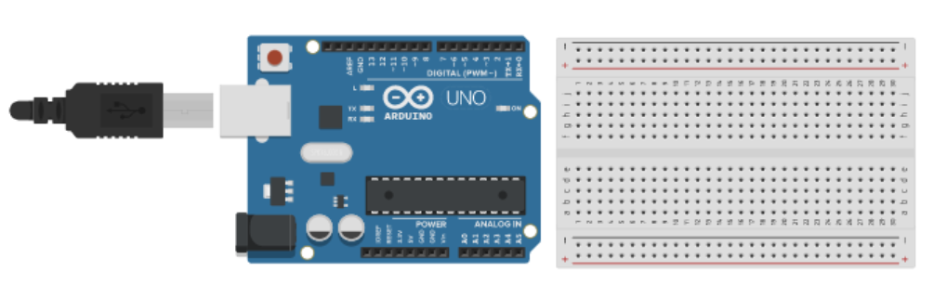
Figure ‎2-3 Connecting Arduino to breadboard

Conclusion and Future Work

Conclusion
In this paragraph, you write a summary of what you presented in the above two chapters. Instead of using expressions like “in our project we will implement ….”, in the conclusion we usually use expressions like “As we could see above, in our project we implemented ……”.
Besides, you need to write about the experiences you learned while taking the course and implementing the project.

Future Work
In this paragraph, you need to write any idea you have about expanding the work you did in your project to be more developed and to be used in real life.

References

[1] | R. J. Smith, "Britannica," 28 Apr 2025. [Online]. Available: https://www.britannica.com/technology/engineering. [Accessed 8 May 2025].
[2] | A. C. o. E. Companies, "ACEC," Yoko Co, 2025. [Online]. Available: https://www.acec.org/about-acec/what-is-engineering/. [Accessed 13 May 2025].
[3] | N. University, "National University," 2025. [Online]. Available: https://www.nu.edu/blog/types-of-engineering/#15-different-types-of-engineering-jobs. [Accessed 13 May 2025].
[4] | W. H. Organization, "World report on vision," World Health Organization, 2019.
[5] | "Arduino Store," [Online]. Available: https://store.arduino.cc/products/arduino-mega-2560-rev3. [Accessed May 2025].
[6] | "Arduino Docs," [Online]. Available: https://docs.arduino.cc/hardware/mega-2560/. [Accessed May 2025].

